Отчёт по практическому заданию
Кейс №9. Агенство недвижимости «DomPlus»
Мелконян Тигран Артурович
2026

UX-макет
Ux-макет разработан в Figma: 4 экрана.
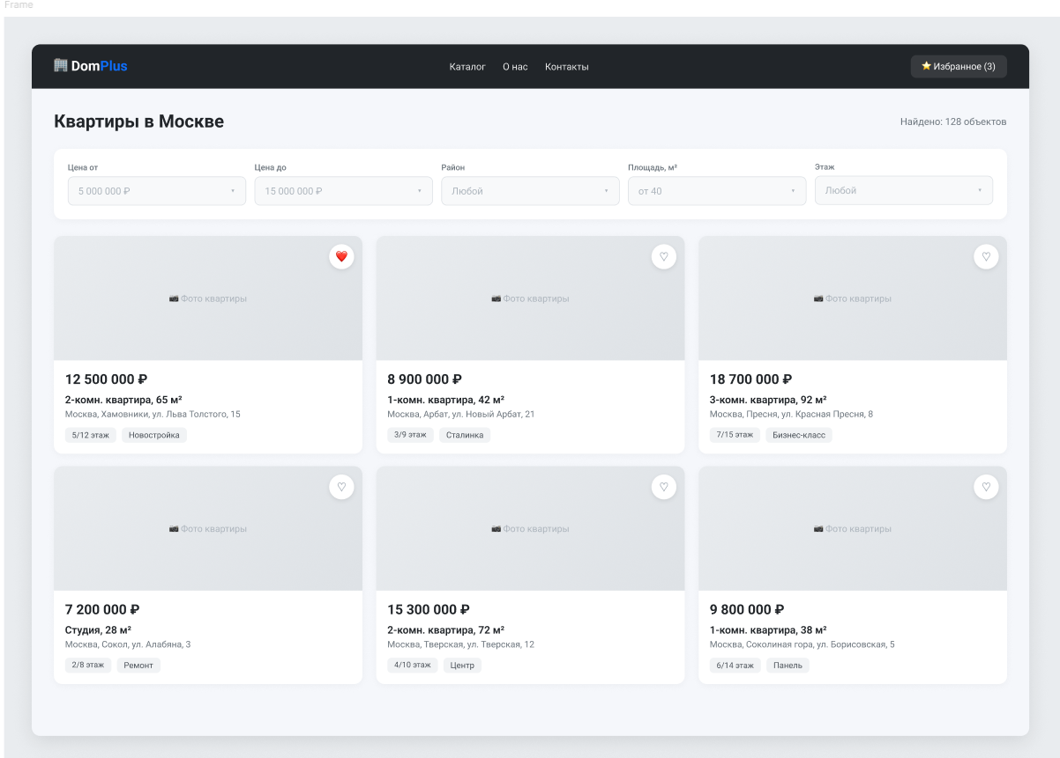
Рис. 1 «каталог квартир»
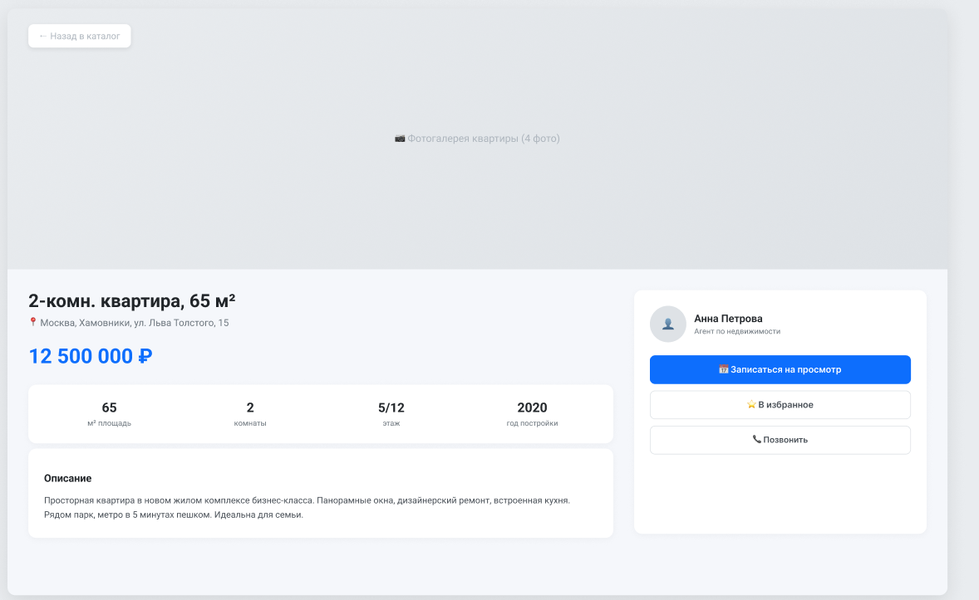
Рис. 2 «карточка квартиры»
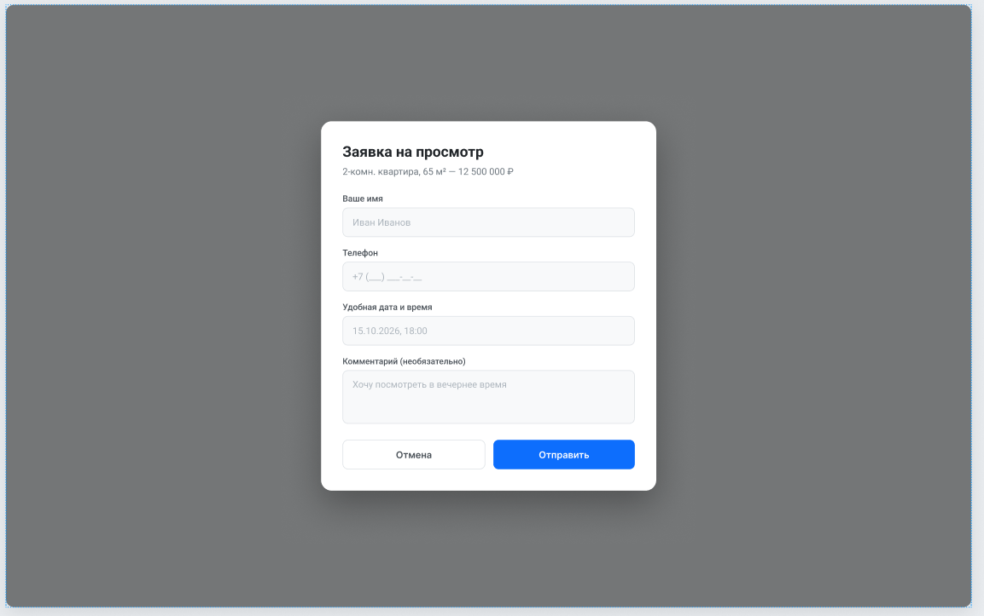
Рис. 3 «модалка заявки на просмотр»
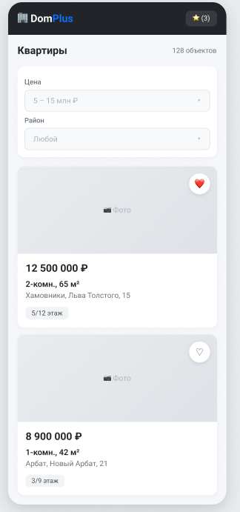
Рис. 4 «адаптивная мобильная версия»
Модель БД
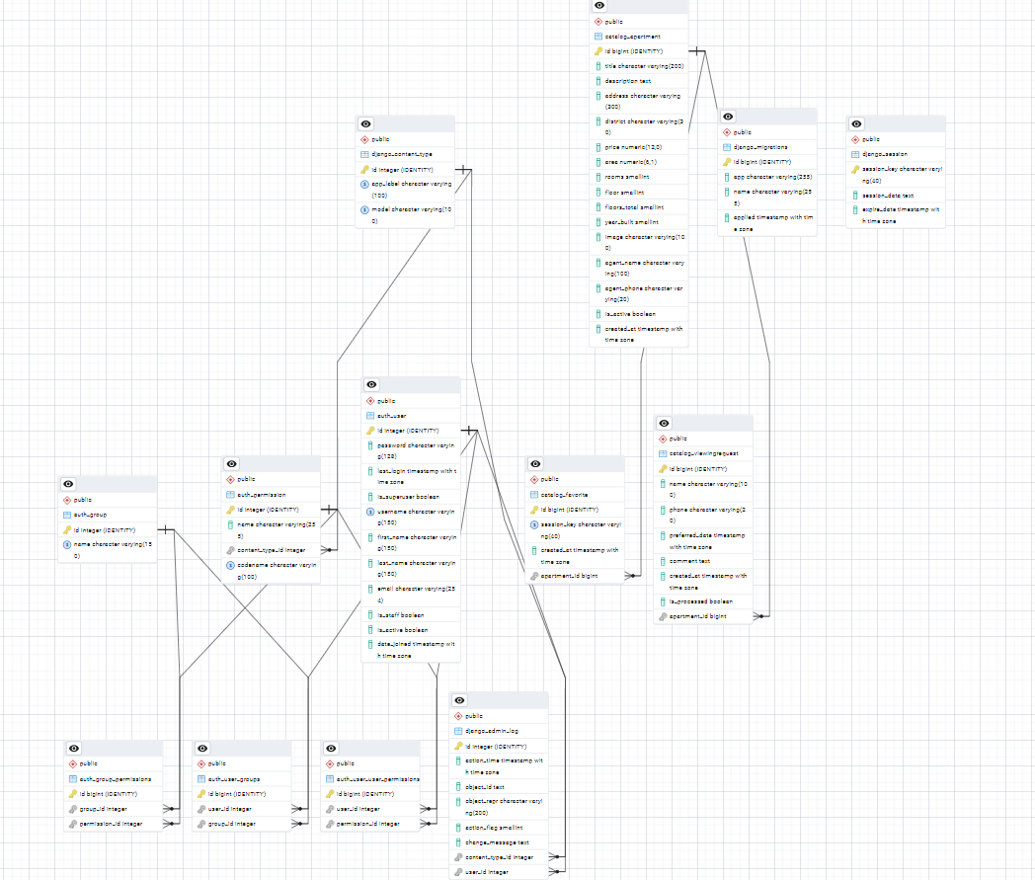
Рис. 5 «модель бд»
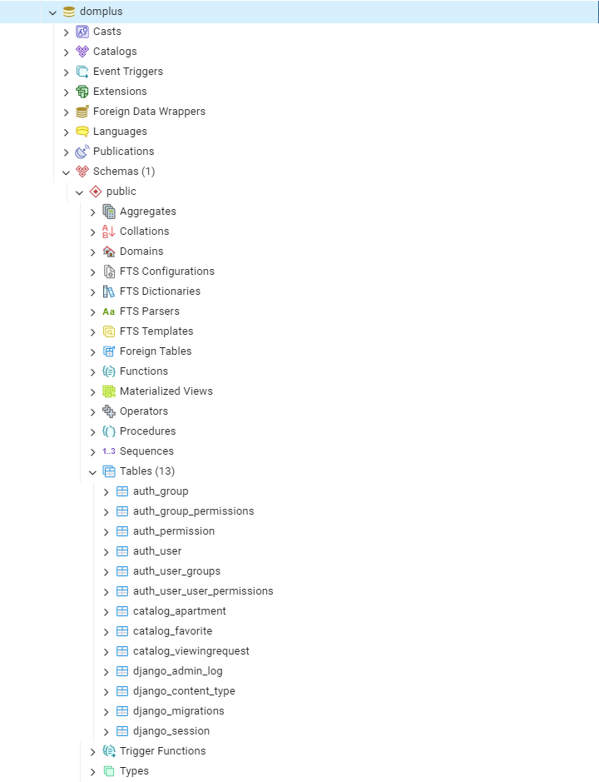
Рис. 6 «структура бд»
Работа приложения
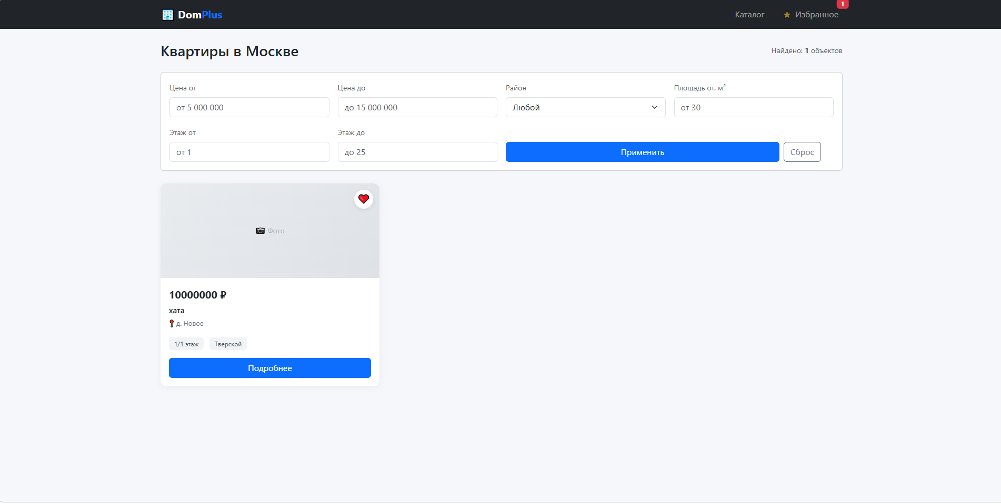
Рис. 7 «каталог квартир»
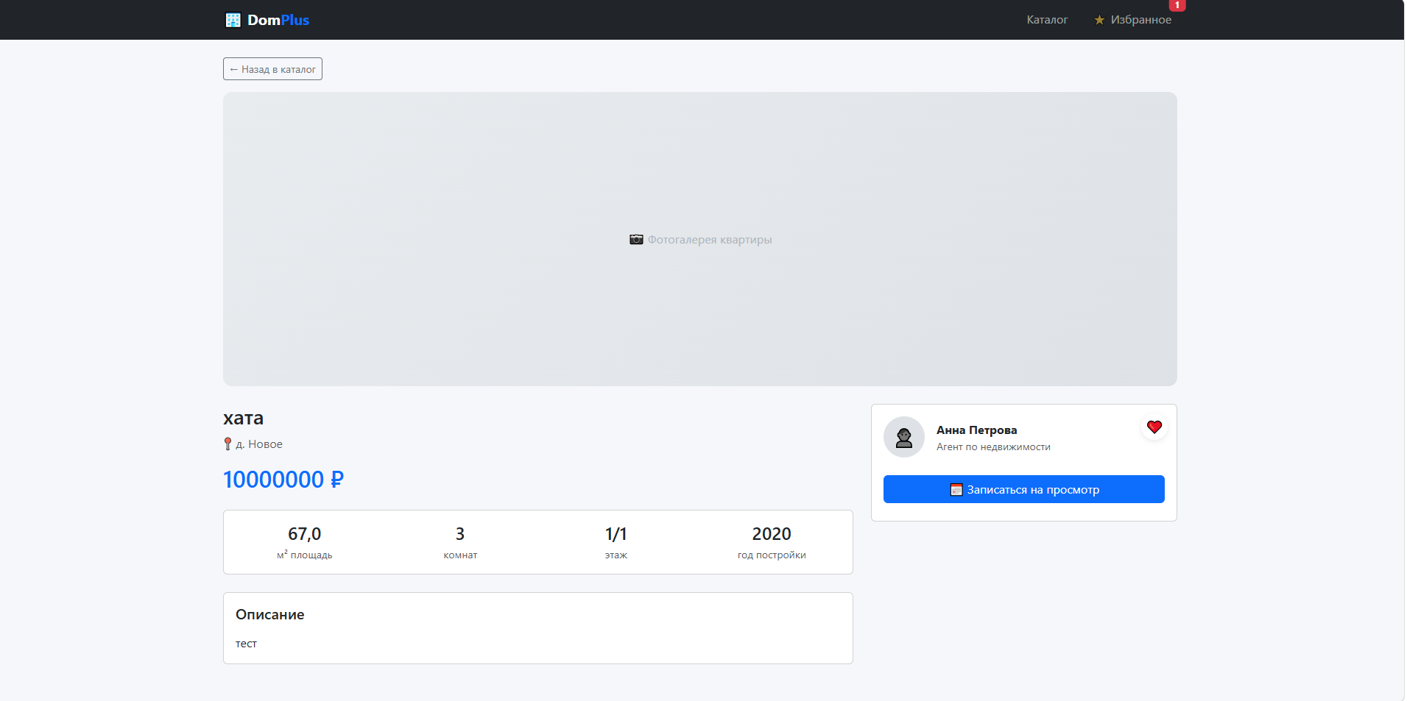
Рис. 8 «карточка товара»
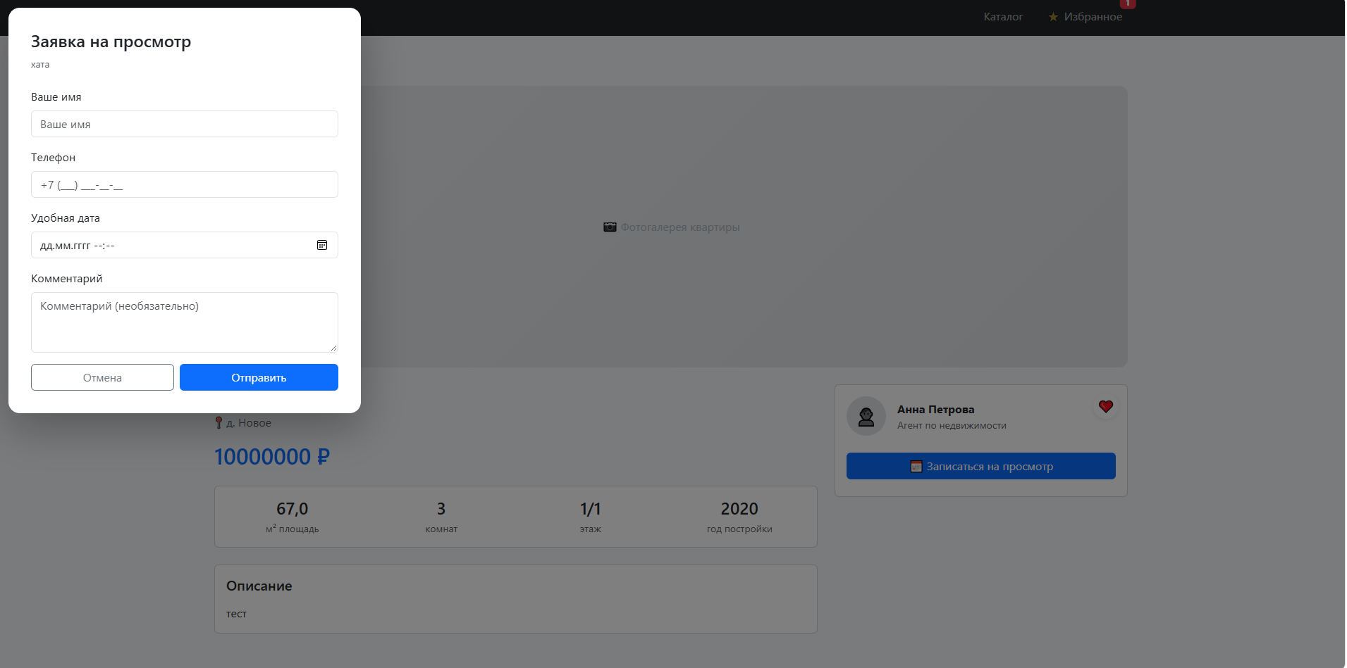
Рис. 9 «Модалка»
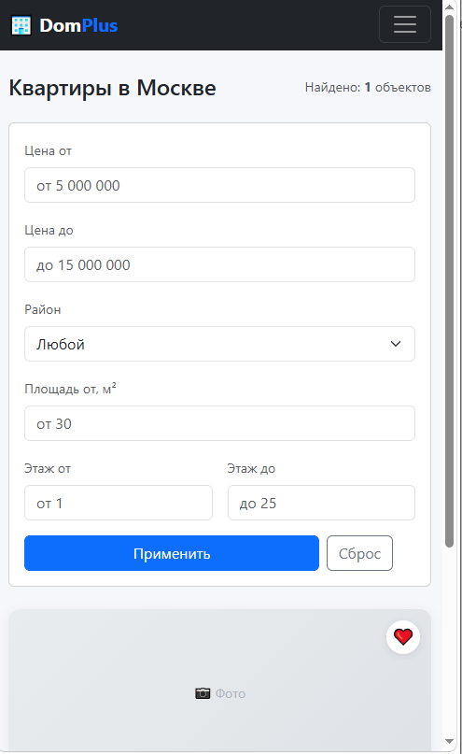
Рис. 10 «Мобильная адаптивная версия»
Коды
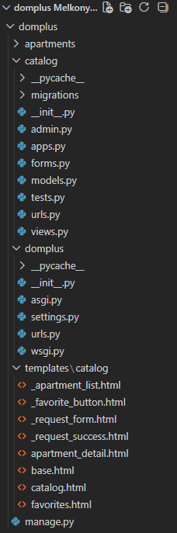
Рис. 11 «Структура проекта»
Catalog/admin.py
from django.contrib import admin
from .models import Apartment, Favorite, ViewingRequest

@admin.register(Apartment)
class ApartmentAdmin(admin.ModelAdmin):
list_display = ('title', 'district', 'price', 'area', 'rooms', 'floor', 'is_active')
list_filter = ('district', 'is_active', 'rooms')
search_fields = ('title', 'address', 'description')
list_editable = ('is_active',)
ordering = ('-created_at',)

@admin.register(Favorite)
class FavoriteAdmin(admin.ModelAdmin):
list_display = ('apartment', 'session_key', 'created_at')
list_filter = ('created_at',)

@admin.register(ViewingRequest)
class ViewingRequestAdmin(admin.ModelAdmin):
list_display = ('name', 'phone', 'apartment', 'preferred_date', 'is_processed', 'created_at')
list_filter = ('is_processed', 'created_at')
search_fields = ('name', 'phone', 'apartment__title')
list_editable = ('is_processed',)
Catalog/forms.py
from django import forms
from .models import ViewingRequest, Apartment

class ViewingRequestForm(forms.ModelForm):
class Meta:
model = ViewingRequest
fields = ['name', 'phone', 'preferred_date', 'comment']
widgets = {
'name': forms.TextInput(attrs={
'class': 'form-control', 'placeholder': 'Ваше имя'
}),
'phone': forms.TextInput(attrs={
'class': 'form-control', 'placeholder': '+7 (___) ___-__-__'
}),
'preferred_date': forms.DateTimeInput(
attrs={'class': 'form-control', 'type': 'datetime-local'},
format='%Y-%m-%dT%H:%M',
),
'comment': forms.Textarea(attrs={
'class': 'form-control', 'rows': 3,
'placeholder': 'Комментарий (необязательно)'
}),
}

def __init__(self, *args, **kwargs):
super().__init__(*args, **kwargs)
self.fields['preferred_date'].input_formats = ['%Y-%m-%dT%H:%M']
self.fields['preferred_date'].required = False

class ApartmentFilterForm(forms.Form):
"""Форма фильтров для каталога (используется в GET-запросе)."""
price_min = forms.DecimalField(
required=False, min_value=0,
widget=forms.NumberInput(attrs={
'class': 'form-control', 'placeholder': 'от 5 000 000'
}),
)
price_max = forms.DecimalField(
required=False, min_value=0,
widget=forms.NumberInput(attrs={
'class': 'form-control', 'placeholder': 'до 15 000 000'
}),
)
district = forms.ChoiceField(
required=False,
choices=[('', 'Любой')] + list(Apartment.District.choices),
widget=forms.Select(attrs={'class': 'form-select'}),
)
area_min = forms.DecimalField(
required=False, min_value=0,
widget=forms.NumberInput(attrs={
'class': 'form-control', 'placeholder': 'от 30'
}),
)
floor_min = forms.IntegerField(
required=False, min_value=1,
widget=forms.NumberInput(attrs={
'class': 'form-control', 'placeholder': 'от 1'
}),
)
floor_max = forms.IntegerField(
required=False, min_value=1,
widget=forms.NumberInput(attrs={
'class': 'form-control', 'placeholder': 'до 25'
}),
)
Catalog/models.py
from django.conf import settings
from django.db import models
from django.urls import reverse

class Apartment(models.Model):
"""Квартира в каталоге."""

class District(models.TextChoices):
KHAMOVNIKI = 'khamovniki', 'Хамовники'
ARBAT = 'arbat', 'Арбат'
PRESNYA = 'presnya', 'Пресня'
SOKOL = 'sokol', 'Сокол'
TVERSKOY = 'tverskoy', 'Тверской'
SOKOLINAYA = 'sokolinaya', 'Соколиная гора'
OTHER = 'other', 'Другой'

title = models.CharField('Заголовок', max_length=200)
description = models.TextField('Описание', blank=True)
address = models.CharField('Адрес', max_length=300)
district = models.CharField(
'Район', max_length=30,
choices=District.choices,
default=District.OTHER,
)
price = models.DecimalField('Цена, ₽', max_digits=12, decimal_places=0)
area = models.DecimalField('Площадь, м²', max_digits=6, decimal_places=1)
rooms = models.PositiveSmallIntegerField('Комнат')
floor = models.PositiveSmallIntegerField('Этаж')
floors_total = models.PositiveSmallIntegerField('Этажей в доме')
year_built = models.PositiveSmallIntegerField('Год постройки', null=True, blank=True)
image = models.ImageField('Фото', upload_to='apartments/', blank=True, null=True)
agent_name = models.CharField('Агент', max_length=100, default='Анна Петрова')
agent_phone = models.CharField('Телефон агента', max_length=20, blank=True)
is_active = models.BooleanField('Активна', default=True)
created_at = models.DateTimeField(auto_now_add=True)

class Meta:
ordering = ['-created_at']
verbose_name = 'Квартира'
verbose_name_plural = 'Квартиры'
indexes = [
models.Index(fields=['district', 'price']),
models.Index(fields=['-created_at']),
]

def __str__(self):
return f'{self.title} — {self.price:,.0f} ₽'.replace(',', ' ')

def get_absolute_url(self):
return reverse('apartment_detail', args=[self.pk])

class Favorite(models.Model):
"""Избранное пользователя (по session_key, без обязательной авторизации)."""
session_key = models.CharField('Ключ сессии', max_length=40, db_index=True)
apartment = models.ForeignKey(
Apartment, on_delete=models.CASCADE,
related_name='favorites', verbose_name='Квартира',
)
created_at = models.DateTimeField(auto_now_add=True)

class Meta:
unique_together = ('session_key', 'apartment')
verbose_name = 'Избранное'
verbose_name_plural = 'Избранное'

def __str__(self):
return f'{self.session_key[:8]}... → {self.apartment}'

class ViewingRequest(models.Model):
"""Заявка на просмотр квартиры."""
apartment = models.ForeignKey(
Apartment, on_delete=models.CASCADE,
related_name='requests', verbose_name='Квартира',
)
name = models.CharField('Имя', max_length=100)
phone = models.CharField('Телефон', max_length=20)
preferred_date = models.DateTimeField('Желаемая дата', null=True, blank=True)
comment = models.TextField('Комментарий', blank=True)
created_at = models.DateTimeField(auto_now_add=True)
is_processed = models.BooleanField('Обработана', default=False)

class Meta:
ordering = ['-created_at']
verbose_name = 'Заявка на просмотр'
verbose_name_plural = 'Заявки на просмотр'

def __str__(self):
return f'{self.name} — {self.apartment.title}'
Catalog/urls.py
from django.urls import path
from . import views

urlpatterns = [
path('', views.catalog, name='catalog'),
path('apartment/<int:pk>/', views.apartment_detail, name='apartment_detail'),
path('favorite/<int:pk>/toggle/', views.toggle_favorite, name='toggle_favorite'),
path('favorites/', views.favorites_list, name='favorites_list'),
path('request/<int:pk>/', views.submit_request, name='submit_request'),
]
Catalog/views.py
from django.core.paginator import Paginator
from django.http import HttpResponse
from django.shortcuts import render, get_object_or_404, redirect
from django.template.loader import render_to_string
from django.views.decorators.http import require_POST
from django.db.models import Q, Min, Max

from .models import Apartment, Favorite, ViewingRequest
from .forms import ApartmentFilterForm, ViewingRequestForm

# ============ СЕССИЯ (для избранного без логина) ============
def _ensure_session(request):
if not request.session.session_key:
request.session.create()
return request.session.session_key

# ============ ФИЛЬТРАЦИЯ (общая логика) ============
def _filter_apartments(request):
qs = Apartment.objects.filter(is_active=True)

price_min = request.GET.get('price_min')
price_max = request.GET.get('price_max')
district = request.GET.get('district')
area_min = request.GET.get('area_min')
floor_min = request.GET.get('floor_min')
floor_max = request.GET.get('floor_max')

if price_min:
qs = qs.filter(price__gte=price_min)
if price_max:
qs = qs.filter(price__lte=price_max)
if district:
qs = qs.filter(district=district)
if area_min:
qs = qs.filter(area__gte=area_min)
if floor_min:
qs = qs.filter(floor__gte=floor_min)
if floor_max:
qs = qs.filter(floor__lte=floor_max)

return qs

def _favorites_ids(request):
session_key = request.session.session_key
if not session_key:
return []
return list(
Favorite.objects.filter(session_key=session_key)
.values_list('apartment_id', flat=True)
)

# ============ КАТАЛОГ ============
def catalog(request):
session_key = _ensure_session(request)
qs = _filter_apartments(request)

paginator = Paginator(qs, 6)
page_number = request.GET.get('page', 1)
page_obj = paginator.get_page(page_number)

context = {
'page_obj': page_obj,
'apartments': page_obj.object_list,
'filter_form': ApartmentFilterForm(request.GET or None),
'favorites': _favorites_ids(request),
'favorites_count': Favorite.objects.filter(session_key=session_key).count(),
'total_count': qs.count(),
'is_htmx': request.headers.get('HX-Request') == 'true',
}

# HTMX-запрос — возвращаем ТОЛЬКО список карточек
if context['is_htmx']:
return render(request, 'catalog/_apartment_list.html', context)

return render(request, 'catalog/catalog.html', context)

# ============ КАРТОЧКА КВАРТИРЫ ============
def apartment_detail(request, pk):
session_key = _ensure_session(request)
apartment = get_object_or_404(Apartment, pk=pk, is_active=True)

context = {
'apartment': apartment,
'form': ViewingRequestForm(),
'is_favorite': Favorite.objects.filter(
session_key=session_key, apartment=apartment
).exists(),
'favorites_count': Favorite.objects.filter(session_key=session_key).count(),
}
return render(request, 'catalog/apartment_detail.html', context)

# ============ ИЗБРАННОЕ (HTMX) ============
@require_POST
def toggle_favorite(request, pk):
session_key = _ensure_session(request)
apartment = get_object_or_404(Apartment, pk=pk)

fav, created = Favorite.objects.get_or_create(
session_key=session_key, apartment=apartment
)
if not created:
fav.delete()
is_favorite = False
else:
is_favorite = True

count = Favorite.objects.filter(session_key=session_key).count()

return render(request, 'catalog/_favorite_button.html', {
'apartment': apartment,
'is_favorite': is_favorite,
'favorites_count': count,
})

# ============ СПИСОК ИЗБРАННОГО ============
def favorites_list(request):
session_key = _ensure_session(request)
favorites = Favorite.objects.filter(session_key=session_key).select_related('apartment')
apartments = [f.apartment for f in favorites]

context = {
'apartments': apartments,
'favorites': [a.pk for a in apartments],
'favorites_count': len(apartments),
}
return render(request, 'catalog/favorites.html', context)

# ============ ЗАЯВКА НА ПРОСМОТР (HTMX) ============
@require_POST
def submit_request(request, pk):
apartment = get_object_or_404(Apartment, pk=pk)
form = ViewingRequestForm(request.POST)

if form.is_valid():
obj = form.save(commit=False)
obj.apartment = apartment
obj.save()
return render(request, 'catalog/_request_success.html', {'apartment': apartment})

return render(request, 'catalog/_request_form.html', {
'form': form, 'apartment': apartment
})
domplus/urls.py
from django.contrib import admin
from django.urls import path, include

urlpatterns = [
path('admin/', admin.site.urls),
path('', include('catalog.urls')),
]
templates/catalog/base.html
{% load static %}
<!doctype html>
<html lang="ru">
<head>
<meta charset="utf-8">
<meta name="viewport" content="width=device-width, initial-scale=1">
<title>{% block title %}DomPlus{% endblock %}</title>
<link href="https://cdn.jsdelivr.net/npm/bootstrap@5.3.3/dist/css/bootstrap.min.css" rel="stylesheet">
<link href="https://cdn.jsdelivr.net/npm/bootstrap-icons@1.11.3/font/bootstrap-icons.css" rel="stylesheet">
<style>
body { background: #f5f7fb; }
.navbar-brand { font-weight: 700; }
.navbar-brand span { color: #0d6efd; }
.apt-card { border: none; border-radius: 12px; overflow: hidden;
box-shadow: 0 2px 12px rgba(0,0,0,.05); transition: transform .2s; }
.apt-card:hover { transform: translateY(-4px); box-shadow: 0 8px 24px rgba(0,0,0,.1); }
.apt-img { height: 180px; background: linear-gradient(135deg,#e9ecef,#dee2e6);
display: flex; align-items: center; justify-content: center;
color: #adb5bd; font-size: 14px; position: relative; }
.apt-price { font-size: 20px; font-weight: 700; color: #212529; }
.apt-title { font-size: 15px; font-weight: 600; }
.apt-sub { font-size: 13px; color: #6c757d; }
.apt-tag { background: #f1f3f5; padding: 4px 10px; border-radius: 6px;
font-size: 12px; color: #495057; margin-right: 6px; }
.fav-btn { position: absolute; top: 12px; right: 12px;
width: 36px; height: 36px; background: white; border-radius: 50%;
display: flex; align-items: center; justify-content: center;
box-shadow: 0 2px 8px rgba(0,0,0,.1); cursor: pointer;
border: none; font-size: 18px; color: #adb5bd; }
.fav-btn.active { color: #dc3545; }
.htmx-indicator { opacity: 0; transition: opacity .2s; }
.htmx-request .htmx-indicator { opacity: 1; }
.htmx-request.htmx-indicator { opacity: 1; }
.spinner { display: inline-block; width: 1rem; height: 1rem;
border: 2px solid rgba(0,0,0,.1); border-top-color: #0d6efd;
border-radius: 50%; animation: spin 1s linear infinite; }
@keyframes spin { to { transform: rotate(360deg); } }
</style>
</head>
<body>

<nav class="navbar navbar-expand-lg navbar-dark bg-dark mb-4">
<div class="container">
<a class="navbar-brand" href="{% url 'catalog' %}">🏢 Dom<span>Plus</span></a>
<button class="navbar-toggler" data-bs-toggle="collapse" data-bs-target="#nav">
<span class="navbar-toggler-icon"></span>
</button>
<div class="collapse navbar-collapse" id="nav">
<ul class="navbar-nav ms-auto align-items-lg-center gap-lg-3">
<li class="nav-item"><a class="nav-link" href="{% url 'catalog' %}">Каталог</a></li>
<li class="nav-item">
<a class="nav-link position-relative" href="{% url 'favorites_list' %}">
⭐ Избранное
<span id="fav-counter"
class="badge bg-danger position-absolute top-0 start-100 translate-middle">
{{ favorites_count|default:0 }}
</span>
</a>
</li>
</ul>
</div>
</div>
</nav>

<main class="container pb-5">
{% block content %}{% endblock %}
</main>

<!-- HTMX -->
<script src="https://unpkg.com/htmx.org@1.9.12"></script>
<!-- Alpine.js -->
<script defer src="https://unpkg.com/alpinejs@3.14.1/dist/cdn.min.js"></script>
<!-- Bootstrap -->
<script src="https://cdn.jsdelivr.net/npm/bootstrap@5.3.3/dist/js/bootstrap.bundle.min.js"></script>

<script>
// CSRF для HTMX POST-запросов
document.body.addEventListener('htmx:configRequest', (e) => {
e.detail.headers['X-CSRFToken'] = '{{ csrf_token }}';
});
</script>
{% block scripts %}{% endblock %}
</body>
</html>
templates/catalog/catalog.html
{% extends 'catalog/base.html' %}
{% block title %}Каталог квартир — DomPlus{% endblock %}

{% block content %}

<div class="d-flex flex-wrap justify-content-between align-items-center mb-4 gap-2">
<h1 class="h3 mb-0">Квартиры в Москве</h1>
<div class="text-muted small">
Найдено: <strong id="total-count">{{ total_count }}</strong> объектов
</div>
</div>

<!-- ФИЛЬТРЫ (HTMX) -->
<form id="filter-form"
hx-get="{% url 'catalog' %}"
hx-target="#apartment-list"
hx-trigger="change, submit"
hx-indicator="#filter-spinner"
hx-push-url="true"
class="card mb-4">
<div class="card-body">
<div class="row g-3">
<div class="col-12 col-md-6 col-lg-3">
<label class="form-label small text-muted">Цена от</label>
{{ filter_form.price_min }}
</div>
<div class="col-12 col-md-6 col-lg-3">
<label class="form-label small text-muted">Цена до</label>
{{ filter_form.price_max }}
</div>
<div class="col-12 col-md-6 col-lg-3">
<label class="form-label small text-muted">Район</label>
{{ filter_form.district }}
</div>
<div class="col-12 col-md-6 col-lg-3">
<label class="form-label small text-muted">Площадь от, м²</label>
{{ filter_form.area_min }}
</div>
<div class="col-6 col-lg-3">
<label class="form-label small text-muted">Этаж от</label>
{{ filter_form.floor_min }}
</div>
<div class="col-6 col-lg-3">
<label class="form-label small text-muted">Этаж до</label>
{{ filter_form.floor_max }}
</div>
<div class="col-12 col-lg-6 d-flex align-items-end gap-2">
<button type="submit" class="btn btn-primary flex-grow-1">
Применить
</button>
<a href="{% url 'catalog' %}" class="btn btn-outline-secondary">Сброс</a>
<span id="filter-spinner" class="htmx-indicator">
<span class="spinner"></span>
</span>
</div>
</div>
</div>
</form>

<!-- СПИСОК КВАРТИР (цель для HTMX) -->
<div id="apartment-list">
{% include 'catalog/_apartment_list.html' %}
</div>

{% endblock %}
templates/catalog/favorites.html
{% extends 'catalog/base.html' %}
{% block title %}Избранное — DomPlus{% endblock %}

{% block content %}

<h1 class="h3 mb-4">⭐ Избранное</h1>

{% if apartments %}
<div class="row g-4">
{% for apt in apartments %}
<div class="col-12 col-md-6 col-lg-4">
<div class="card apt-card h-100">
<div class="apt-img">
📷 Фото
{% include 'catalog/_favorite_button.html' with apartment=apt is_favorite=True %}
</div>
<div class="card-body d-flex flex-column">
<div class="apt-price mb-1">{{ apt.price|floatformat:0 }} ₽</div>
<div class="apt-title mb-1">{{ apt.title }}</div>
<div class="apt-sub mb-3">📍 {{ apt.address }}</div>
<a href="{% url 'apartment_detail' apt.pk %}" class="btn btn-primary mt-auto">
Подробнее
</a>
</div>
</div>
</div>
{% endfor %}
</div>
{% else %}
<div class="text-center p-5 text-muted">
<h4>В избранном пока пусто</h4>
<p>Добавляйте квартиры, нажав на ❤ в каталоге</p>
<a href="{% url 'catalog' %}" class="btn btn-primary">Перейти в каталог</a>
</div>
{% endif %}

{% endblock %}
templates/catalog/apartment_detail.html
{% extends 'catalog/base.html' %}
{% block title %}{{ apartment.title }} — DomPlus{% endblock %}

{% block content %}

<a href="{% url 'catalog' %}" class="btn btn-outline-secondary btn-sm mb-3">← Назад в каталог</a>

<div class="card mb-4" style="border:none;border-radius:12px;overflow:hidden;">
<div style="height:400px;background:linear-gradient(135deg,#e9ecef,#dee2e6);
display:flex;align-items:center;justify-content:center;
color:#adb5bd;font-size:16px;">
📷 Фотогалерея квартиры
</div>
</div>

<div class="row g-4">
<div class="col-12 col-lg-8">
<h1 class="h3 mb-2">{{ apartment.title }}</h1>
<p class="text-muted mb-3">📍 {{ apartment.address }}</p>
<div class="h2 text-primary mb-4">{{ apartment.price|floatformat:0 }} ₽</div>

<div class="card mb-4">
<div class="card-body">
<div class="row text-center">
<div class="col-3">
<div class="h4 mb-1">{{ apartment.area }}</div>
<div class="small text-muted">м² площадь</div>
</div>
<div class="col-3">
<div class="h4 mb-1">{{ apartment.rooms }}</div>
<div class="small text-muted">комнат</div>
</div>
<div class="col-3">
<div class="h4 mb-1">{{ apartment.floor }}/{{ apartment.floors_total }}</div>
<div class="small text-muted">этаж</div>
</div>
<div class="col-3">
<div class="h4 mb-1">{{ apartment.year_built|default:"—" }}</div>
<div class="small text-muted">год постройки</div>
</div>
</div>
</div>
</div>

{% if apartment.description %}
<div class="card">
<div class="card-body">
<h5 class="mb-3">Описание</h5>
<p class="mb-0">{{ apartment.description }}</p>
</div>
</div>
{% endif %}
</div>

<div class="col-12 col-lg-4">
<div class="card" style="position:sticky;top:24px;">
<div class="card-body">
<div class="d-flex gap-3 align-items-center mb-4">
<div style="width:56px;height:56px;background:#dee2e6;border-radius:50%;
display:flex;align-items:center;justify-content:center;font-size:24px;">
👤
</div>
<div>
<div class="fw-bold">{{ apartment.agent_name }}</div>
<div class="small text-muted">Агент по недвижимости</div>
</div>
</div>

<!-- Кнопка заявки — открывает Alpine.js модалку -->
<button class="btn btn-primary w-100 mb-2"
@click="$dispatch('open-request-modal')"
x-data>
📅 Записаться на просмотр
</button>

<!-- Избранное -->
{% if is_favorite %}
{% include 'catalog/_favorite_button.html' with apartment=apartment is_favorite=True %}
{% else %}
{% include 'catalog/_favorite_button.html' with apartment=apartment is_favorite=False %}
{% endif %}

{% if apartment.agent_phone %}
<a href="tel:{{ apartment.agent_phone }}" class="btn btn-outline-secondary w-100 mt-2">
📞 Позвонить
</a>
{% endif %}
</div>
</div>
</div>
</div>

<!-- МОДАЛКА ЗАЯВКИ (Alpine.js) -->
<div x-data="{ open: false }"
@open-request-modal.window="open = true"
@keydown.escape.window="open = false"
x-show="open"
x-cloak
style="position:fixed;inset:0;background:rgba(0,0,0,.5);z-index:1050;
display:flex;align-items:center;justify-content:center;padding:16px;">
<div @click.outside="open = false"
style="background:white;border-radius:16px;max-width:500px;width:100%;
padding:32px;box-shadow:0 20px 60px rgba(0,0,0,.3);">
<h3 class="h4 mb-2">Заявка на просмотр</h3>
<p class="text-muted small mb-4">{{ apartment.title }}</p>

<div id="request-form-container">
{% include 'catalog/_request_form.html' %}
</div>
</div>
</div>

{% endblock %}
templates/catalog/_request_success.html
<div class="text-center py-4">
<div style="font-size:48px;">✅</div>
<h4 class="mt-3">Заявка отправлена!</h4>
<p class="text-muted mb-4">
Мы свяжемся с вами в ближайшее время для подтверждения просмотра.
</p>
<button class="btn btn-primary"
@click="open = false">Закрыть</button>
</div>
templates/catalog/_request_form.html
<form hx-post="{% url 'submit_request' apartment.pk %}"
hx-target="#request-form-container"
hx-swap="innerHTML">
{% csrf_token %}
<div class="mb-3">
<label class="form-label">Ваше имя</label>
{{ form.name }}
</div>
<div class="mb-3">
<label class="form-label">Телефон</label>
{{ form.phone }}
</div>
<div class="mb-3">
<label class="form-label">Удобная дата</label>
{{ form.preferred_date }}
</div>
<div class="mb-3">
<label class="form-label">Комментарий</label>
{{ form.comment }}
</div>
<div class="d-flex gap-2">
<button type="button" class="btn btn-outline-secondary flex-grow-1"
@click="open = false">Отмена</button>
<button type="submit" class="btn btn-primary flex-grow-1">Отправить</button>
</div>
</form>
templates/catalog/_favorite_button.html
<div data-fav-count="{{ favorites_count|default:0 }}" style="display:inline;">
<button class="fav-btn {% if is_favorite %}active{% endif %}"
hx-post="{% url 'toggle_favorite' apartment.pk %}"
hx-target="closest div[data-fav-count]"
hx-swap="outerHTML"
hx-on::after-request="updateFavCounter(event)"
title="Избранное">
{% if is_favorite %}❤{% else %}♡{% endif %}
</button>
</div>

<script>
function updateFavCounter(event) {
const xhr = event.detail.xhr;
const match = xhr.responseText.match(/data-fav-count="(\d+)"/);
if (match) {
document.getElementById('fav-counter').textContent = match[1];
}
}
</script>
templates/catalog/_apartment_list.html
{% if apartments %}
<div class="row g-4">
{% for apt in apartments %}
<div class="col-12 col-md-6 col-lg-4">
<div class="card apt-card h-100">
<div class="apt-img">
📷 Фото
{% if apt.pk in favorites %}
{% include 'catalog/_favorite_button.html' with apartment=apt is_favorite=True %}
{% else %}
{% include 'catalog/_favorite_button.html' with apartment=apt is_favorite=False %}
{% endif %}
</div>
<div class="card-body d-flex flex-column">
<div class="apt-price mb-1">{{ apt.price|floatformat:0 }} ₽</div>
<div class="apt-title mb-1">
<a href="{% url 'apartment_detail' apt.pk %}" class="text-decoration-none text-dark">
{{ apt.title }}
</a>
</div>
<div class="apt-sub mb-3">📍 {{ apt.address }}</div>
<div class="mb-3">
<span class="apt-tag">{{ apt.floor }}/{{ apt.floors_total }} этаж</span>
<span class="apt-tag">{{ apt.get_district_display }}</span>
</div>
<a href="{% url 'apartment_detail' apt.pk %}" class="btn btn-primary mt-auto">
Подробнее
</a>
</div>
</div>
</div>
{% endfor %}
</div>

{% if page_obj.has_other_pages %}
<nav class="mt-4">
<ul class="pagination justify-content-center">
{% if page_obj.has_previous %}
<li class="page-item">
<a class="page-link"
hx-get="?page={{ page_obj.previous_page_number }}{% for k,v in request.GET.items %}{% if k != 'page' %}&{{ k }}={{ v }}{% endif %}{% endfor %}"
hx-target="#apartment-list"
hx-push-url="true"
href="#">← Назад</a>
</li>
{% endif %}
<li class="page-item active">
<span class="page-link">{{ page_obj.number }} / {{ page_obj.paginator.num_pages }}</span>
</li>
{% if page_obj.has_next %}
<li class="page-item">
<a class="page-link"
hx-get="?page={{ page_obj.next_page_number }}{% for k,v in request.GET.items %}{% if k != 'page' %}&{{ k }}={{ v }}{% endif %}{% endfor %}"
hx-target="#apartment-list"
hx-push-url="true"
href="#">Вперёд →</a>
</li>
{% endif %}
</ul>
</nav>
{% endif %}

{% else %}
<div class="text-center p-5 text-muted">
<h4>Ничего не найдено 😔</h4>
<p>Попробуйте изменить фильтры</p>
<a href="{% url 'catalog' %}" class="btn btn-outline-primary">Сбросить фильтры</a>
</div>
{% endif %}
Вывод
Приложение полностью работает: каталог квартир с фильтрами
без перезагрузки (HTMX), избранное с сохранением в БД, форма
заявки в модалке (Alpine.js), пагинация, админка для агентов,
адаптивная вёрстка. Реализация выполнена без React/Vue —
только HTMX и Alpine.js.
GitHub
https://github.com/tigranius1/DomPlus

